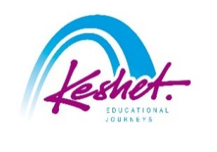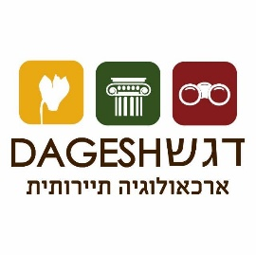

**Digging Deeper:**

**A Hands-on Archaeological Seminar in the Holy Land**

***Led by Archaeologist Dr. Achia Kohn-Tavor***

*October 25-November 11, 2026*

Dagesh Archaeology and Keshet Educational Journeys have joined forces to offer an exclusive opportunity for participants to take an active role in uncovering the history of the Land of Israel. This unique seminar, guided by an expert archaeologist, provides a rare chance to explore hidden historical sites while actively participating in a professional archaeological excavation.

Designed especially for those who have previously visited Israel (but open to anyone) and seek a deeper, more immersive experience, this program takes place at the ancient Jewish village of Chorazin. In addition to the excavation itself, participants will enjoy lectures, guided tours, and hands-on activities that bring history to life.

updatedSeptember 14

|  |  |
| --- | --- |
| **Sunday, October 25:** | ***bruchim Habaim - welcome*** |

* Rendez-vous in Tel Aviv
* Meet your guide, load the bus and head north to the Galilee
* Check into the hotel, followed by a welcome dinner there
* Program Orientation

***Overnight:*** *Galilee*

|  |  |
| --- | --- |
| **Monday, October 26:** | ***Dig in!*** |

* Travel to the Chorazin Excavation Site; tour of the site, followed by an introduction to the excavation process
* First digging session
* Dinner in the hotel
* Evening Lecture: Why the Holy Land?

***Overnight:*** *Galilee*

|  |  |
| --- | --- |
| **Tuesday, October 27:** | ***Digging Deeper*** |

* Morning: excavation of the site, followed by a tour of the ancient synagogue
* Afternoon: Tour of newly-opened Sussita National Park
* Dinner in the hotel
* Evening Lecture: The Archaeology of the Galilee

***Overnight:*** *Galilee*

|  |  |
| --- | --- |
| **Wednesday, October 28:** | ***discovering the past and the present*** |

* Morning: excavation of the site
* Afternoon: ATV Adventure in the Golan
* Dinner in the hotel followed by a free evening in Tiberias

***Overnight:*** *Galilee*

|  |  |
| --- | --- |
| **Thursday, October 29:** | ***mosaic of the galilee*** |

* Morning: excavation of the site
* Afternoon: In Zippori – site where the Mishna was compiled – see some of the most beautiful ancient mosaics in Israel and discuss possible reasons the Oral Law was put into writing
* Continue to Jerusalem and check into your hotel
* Dinner on you own and a free evening in town

***Overnight:*** *Jerusalem*

|  |  |
| --- | --- |
| **Friday, October 30:** | ***this year in jerusalem!*** |

* Guided tour of the archaeology section of the Israel Museum
* Peruse the Machane Yehuda Shuk for sensory overload
* Return to the hotel and prepare for Shabbat
* In the evening, join the thousands of Israelis and Jews from around the world as they bring in Shabbat at the Western Wall
* Return to the hotel for Shabbat dinner

***Overnight:*** *Jerusalem*

|  |  |
| --- | --- |
| **Saturday, October 31:** | ***shabbat shalom*** |

* Free morning in Jerusalem; you may want to:
  + Attend a local Shabbat service
  + Walk around the Christian Quarter and the Arab souq
  + Return to the Israel Museum to see other gems
* Afternoon walking tour of the Via Dolorosa for a tour of the 14 Stations of the Cross, culminating in the Church of the Holy Sepulcher
* Free evening in town

***Overnight:*** *Jerusalem*

|  |  |
| --- | --- |
| **Sunday, November 1:** | ***Judean Desert Adventure*** |

* Depart from Jerusalem
* Jeeping in the Judean Desert to reach off-the-beaten-path sites
* Continue north via the Jordan River Valley
* Tour the ancient ruins of the impressive Beit Shean National Park
* Return to the hotel on the Sea of Galilee (Kinneret)
* Dinner in the hotel

***Overnight:*** *Galilee*

|  |  |
| --- | --- |
| **Monday, November 2:** | ***excavation and biblical landscapes*** |

* Morning: excavation of the site
* Afternoon: Visit the Biblical site of Bethsaida
* Dinner in the hotel
* Evening Lecture: *Judaism* & Christianity in the Galilee / Anci*ent Synagogues of the Region*

***Overnight:*** *Galilee*

|  |  |
| --- | --- |
| **Tuesday, November 3:** | ***piecing together the past*** |

* Morning: excavation of the site
* Workshop: Identifying and Interpreting Ancient Pottery
* Afternoon: travel to Tzfat to explore the alleyways and synagogues of mystics and trace the development of Kabbalah in the 16th Century
* Dinner in the hotel

***Overnight:*** *Galilee*

|  |  |
| --- | --- |
| **Wednesday, November 4:** | ***coins, culture and the sea of galilee*** |

* Morning: excavation of the site
* Workshop: For what it’s worth: Ancient coins and their stories
* Afternoon: Visit to the Yigal Allon Museum adjacent to the hotel
* Boat ride on the sea of Galilee
* Dinner in the hotel

***Overnight:*** *Galilee*

|  |  |
| --- | --- |
| **Thursday, November 5:** | ***rEFLECTION*** |

* Morning: final excavation of the site
* Discussion and wrap-up session: reviewing discoveries and insights
* Fairwell dinner
* Transfer to the airport for your flight home
* Start planning your next trip to Israel!!
* Listed activities and speakers are subject to confirmation.
* Program will be staffed by a Keshet Israel Tour Educator.
* All breakfasts, most lunches plus underlined dinners are included in the package price.
* This itinerary is proprietary to Keshet and is intended for the promotion of and to inform those considering joining this Keshet trip. It is not to be transmitted to any other party without prior authorization from Keshet

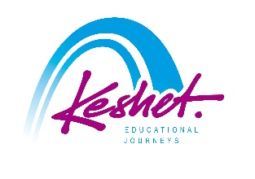

**Keshet Educational Journeys**

PO Box 8540 Jerusalem 91084 Israel

Phone: 972-2-671-3518 | Fax: 972-2-671-3624

keshet@keshetisrael.co.il | www.keshetisrael.co.il