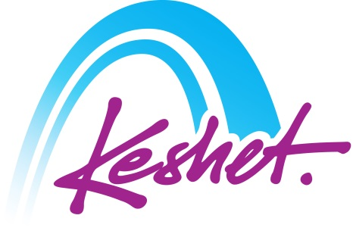
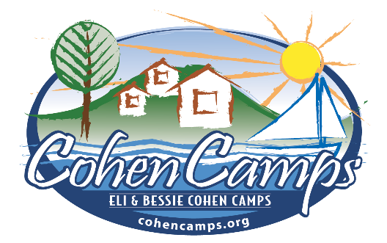

Cohen Camps
Women’s Trip to Israel
Led by Susan Altman
Tour Educator: Kayla Ship
October 22 to November 2, 2023
(rev 19 Jun 23)

Sunday October 22 | DeParture
- Departure from Boston (own air arrangements)

Monday October 23 | bruchim haba’aim-welcome to israel!
- Arrival at Ben Gurion airport in the afternoon (El Al 016 arriving at 13:50)
- (Assistance upon arrival by Keshet representatives).
- Opening tree planting ceremony at the Neot Kedumim Biblical Nature Reserve.
- Outlook over the Port of Jaffa, where pilgrims and olim entered the Holy Land for centuries.
- Welcome Dinner in Tel Aviv’s Yemenite Quarter
- Check-in at hotel
Overnight: Carlton, Tel Aviv

Tuesday October 24 | the first hebrew city
- Breakfast at hotel
- Walk along the “Independence Trail” (modeled after the Freedom Trail) to learn more about the founding of the city of Tel Aviv and the State of Israel.
- Stroll through the weekly arts & crafts fair at Nahalat Binyamin and the Carmel Shuk.
- Lunch stop (on own)
- Docent tour of the Reuven Rubin Museum, focusing on the rebirth of Hebrew culture and art in Tel Aviv’s early years.
- Learn about current events in Israeli society and some Hebrew on a Street Art tour through the Florentine neighborhood.
- Dinner and evening at leisure.
Overnight: Carlton, Tel Aviv

Wednesday October 25 | cosmopolitan tel aviv
- Breakfast at hotel, check-out and load bus.
- Visit with the E4E educational initiative.
- Visit the ANU Museum of Jewish Culture (former Diaspora Museum), including the new Core exhibit as well as the Hallelujah! Assemble, Pray, Study – Synagogues Past and Present exhibit.
- Lunch break (on own) at the Aroma Café at the museum
- Meet Racheli Nagatu and the dedicated faculty of the Yemin Orde Youth Village.
- Continue to Haifa to check-in and freshen up.
- Visit the Druze Village of Usafiyya and enjoy a home hospitality Druze dinner where you’ll learn about Druze culture and religion.
Overnight: Haifa Bayview, Haifa

Thursday October 26 | boston-haifa connection
- Breakfast at hotel
- Outlook over the magnificent Baha’i Gardens and the port of Haifa
- Boston-Haifa Connection-Project focusing on women in Haifa and community service.
- Visit the Hecht Museum of Archaeology on the University of Haifa campus.
- Lunch break (on own) en route.
- En route to Jerusalem, stop at Yvel, a leading jewelry brand worldwide which founded a philanthropic school where Ethiopian immigrants are given a chance to earn a new trade and a possibility for a financially stable life.
- Continue to hotel for check-in.
- Group dinner at local restaurant with female Lone Soldiers living in Israel.
Overnight: Inbal Hotel, Jerusalem

Friday October 27 | this year in jerusalem
- Breakfast at hotel
- Begin the day at the Haas Promenade overlooking the Old City of Jerusalem. Text study and discussion on the Binding of Isaac and whether Abraham passed the test.
- See where Jerusalem first began 3000 years ago, at the City of David. Text study on the story of David and Batsheva (from a women’s perspective) incorporating music and art.
- Shopping time and lunch break (on own) in the Jewish Quarter and Cardo.
- Return to hotel to prepare for shabbat.
- Candle lighting
- We’ll enjoy our own Kabbalat Shabbat service at the Ezrat Yisrael (egalitarian Kotel) prayer space with a guest Chazzanit (song-leader) followed by visit to the Kotel Plaza.
- Festive shabbat dinner at the hotel. Dinner Guest: Representative of Women of the Wall.
Overnight: Inbal Hotel, Jerusalem

Shabbat October 28 | shabbat in jerusalem
- Breakfast at hotel
- Optional Shabbat morning services at local synagogues.
- Day at leisure to explore Jerusalem or enjoy the hotel’s spa facilities and swimming pool.
- (The Biblical Zoo is open 10-5, The Israel Museum is open 10-5, The Tower of David Museum is open 10-2, The Bible Lands Museum is open 10-3, The Botanical Gardens are open 9-5).
- Optional walking tour to the Church of the Holy Sepulchre or of Mishkenot Shaananim with the poetry of Yehuda Amichai.
- Group Havdalah
- Evening: Tower of David “Night Spectacular” sound & light show, projected on the walls of the museum. (Dress warmly as we will be sitting outside)
- Dinner and evening at leisure.
Overnight: Inbal Hotel, Jerusalem

Sunday October 29 | a jewish democratic state (?)
- Breakfast at hotel
- Meeting with Judge Sharon Lari-Bavli of the Jerusalem Magistrates Court who ruled on the Women of the Wall case.
- Enjoy lunch at Café Shalva an inclusive coffee shop at the Shalva National Center which provides programs and services for those with disabilities and their families.
- “The Haredi (Ultra-Orthodox) World” from the perspective of Rochi Ibenboim, a Hassidic woman who founded an organization to prepare other women to enter the workplace.
- Israeli Folk Dancing interactive program- Follow the beat of Israeli women throughout history and culture and experience Israel’s transformation through dance.
- Dinner and evening at leisure
Overnight: Inbal Hotel, Jerusalem

Monday October 30 | what price freedom?
- Early breakfast.
- Depart for the Dead Sea Region. En route, optional photo op with “Shushi” the camel at the “Sea Level” marker.
- Ascend Herod’s mountain fortress of Masada by cable car. Explore why the Jewish rebels chose to live here after the destruction of Jerusalem by the Romans. Descend by cable car.
- Enjoy floating in the therapeutic waters of the Dead Sea at one of the hotels at Ein Bokek including lunch.
- Return to Jerusalem
- Dinner and evening at leisure.
Overnight: Inbal Hotel, Jerusalem

Tuesday October 31 | shoah to tekumah
- Breakfast at hotel
- Hear the personal story of survivor, Rena Quint.
- We learn and remember at the Yad Vashem Holocaust Memorial complex, with visits to the Historical Museum and Childrens’ Memorial.
- Lunch break (on own)
- Visit the Mt. Herzl Cemetery, including the graves of former Prime Minister Golda Meir, and fallen IDF hero, Hannah Senesh.
- “Shuk & Cook” program with dinner at the Machaneh Yehuda Market. Visit some of the vendors for a tasting before splitting into groups to prepare our own meal with a private chef. We’ll receive a recipe booklet so that we can prepare Israeli food back home.
Overnight: Inbal Hotel, Jerusalem

Wednesday November 1 | farewell
- Breakfast at hotel. Check-out and load bus.
- Visit Yad L’Kashish-Lifeline of the Elderly, where shopping is a true mitzvah!
- Visit the beautiful Chagall Windows at the Hadassah Hospital in Ein Karem.
- Lunch break (on own) and shopping time on Ben Yehuda Street.
- Summary discussion and Farewell Dinner
- Transfer to airport for departing flights.

Thursday November 2 | bashana haba’ah
- El Al 015 at 1:05am. Arrival in Boston at 5:45am.

- Listed activities and speakers are subject to confirmation.
- Program will be staffed by a Keshet Israel Tour Educator.
- All breakfasts plus underlined meals are included in the package price.
- This itinerary is proprietary to Keshet and is intended for the promotion of and to inform those considering joining this Keshet trip. It is not to be transmitted to any other party without prior authorization from Keshet

Keshet Educational Journeys
PO Box 8540 Jerusalem 91084 Israel
Phone: 972-2-671-3518 | Fax: 972-2-671-3624
keshet@keshetisrael.co.il | www.keshetisrael.co.il

