Join Zenia & Jeffrey Cohen
Litvak Jewish Heritage Tour
to Lithuania and Latvia
March 10 – 14, 2024
(Itinerary as of July 24 - Subject to Change)

Led by Rabbi Mitchell Ackerson
_____________________________________________________________________________________________
Sunday March 10
- Midday arrival in Vilna
- Visit the Vilna Gaon State Museum Tolerance Center and Holocaust Exposition,
- Introduction to Lithuania and Litvak Jewish Identity. There were 160,000 Jews in Lithuania before WWII making up 7% of the population. Over 100,000 lived in Vilna where Jews made up 45% of the population.
- Dinner with members of the local Jewish community
Overnight: Conti Hotel, Vilnius
_____________________________________________________________________________________________
Monday March 11
- Breakfast
- Explore the Medieval streets of Vilna and learn how Vilna became known as the Jerusalem of Lithuania.
- Visit the Choral Synagogue, built in 1903 and currently the only active synagogue in Vilna
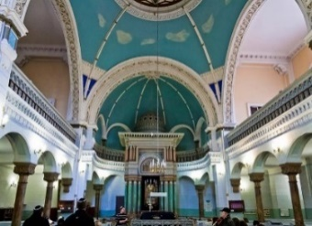
- See the Ghetto Memorials and other sites that testify to the significant Jewish history in Vilna.
- Lunch
- Visit the Jewish Cemetery in Suderve which includes the tomb of the Rabbi Eliyahu ben Sholom Zalman (1720-1790) the towering Rabbinic figure known as the Vilna Gaon
- Walking tour through Vilnius Old Town including Vilnius Cathedral Square
- Dinner
- Lithuanian Folklore Show
Overnight: Conti Hotel, Vilnius
_____________________________________________________________________________________________
Tuesday March 12
- Breakfast
- Pack bus and depart Vilna to stand in solemn memory at the Paneriai Forest Memorial (Ponar) where most of the Jews of Vilna were murdered by the Germans and their Lithuanian allies
- Continue to Trakai, once home to important (Rabbinite) Jewish and Karaite communities.
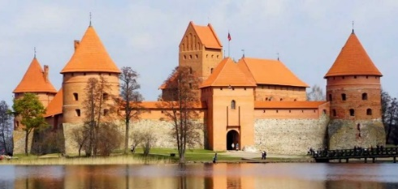
- Visit the Karaite Kenesa (Synagogue) and Museum and learn about the history of the Karaite and Jewish communities of Trakai. In 1897, the town population included 377 Karaites and 1,112 Rabbinite Jews, out of a general population of 3,240.
- Packed Lunch
- Visit the Trakai Island Castle whose construction began in the 14th century.
- Continue to Ziezmariai to see one of the very few wooden synagogues to survive the Shoah. In 1940 the 200 Jewish families of the town made up nearly 50 percent of the total population.
- Continue to Kaunas (Kovno). The 38,000 Jews of Kovno were 30% of the population before the Shoa
- Stand in solemn memory at the dramatic Ninth Fort Kaunas Holocaust Memorial where the Germans and their Lithuanian allies murdered over 15,000 Jews.
- Dinner and session with members of the Jewish community at the Jewish Community Center
Overnight: Radisson Hotel, Kaunas
_____________________________________________________________________________________________
Wednesday March 13
- Breakfast
- Pack bus and depart hotel
- Learn the inspiring story of Japanese diplomat Chiune Sugihara at the museum which was established in the home where he lived with his family. The museum tells the story of his efforts together with Dutch businessman and diplomat Jan Zwartendijk to save thousands of Jews.
- Visit the neo-baroque Kaunas Choral Synagogue built in 1872
- Lunch
- Head to the Kovno Ghetto Memorial and see the site of the famed Slobodka Yeshivah
- Continue to Riga, capital of Latvia
- Dinner
Overnight: Welton Riverside Hotel, Riga
_____________________________________________________________________________________________
Thursday March 14
- Breakfast at the hotel
- Visit the memorial site of the Great Choral Synagogue destroyed by the Nazis in July 1941 and the Riga Ghetto and Latvian Holocaust Memorials. Prior to the Holocaust, Riga was home to almost 44,000 Jewish inhabitants making up 11% of the city population
- Tour the Jews in Latvia Museum at the Riga Jewish Community Center.
- Stand in solemn memory in the Rumbula Forest where 25,000 Jews (mostly from the Riga Ghetto) were murdered by Germans and Latvians in November and December 1941.
- Late lunch with members of the Jewish community and learn about the challenges facing the community
- Head to the airport for flights to Israel
____________________________________________________________________________________
- Listed activities and speakers are subject to confirmation.
- All meals are included in the package price.

Trip extensions before or after the trip can be arranged (at additional cost)

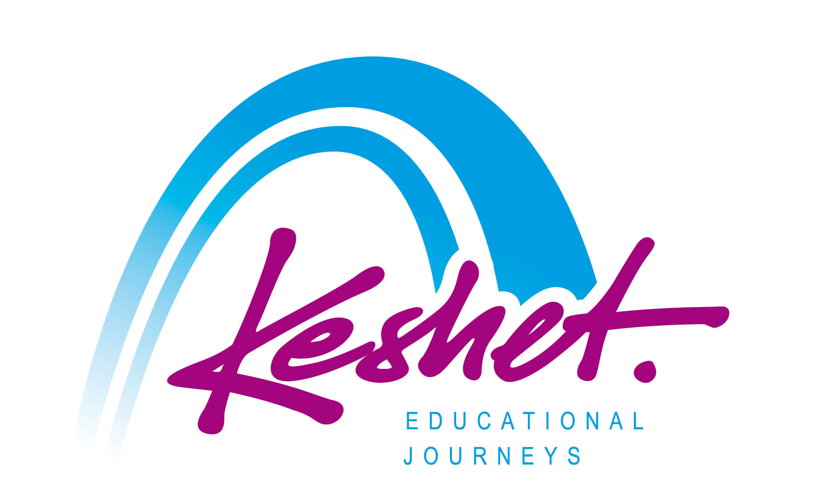

Keshet Educational Journeys
PO Box 8540 Jerusalem 91084 Israel
Phone: 972-2-671-3518 | Fax: 972-2-671-3624

danny@keshetisrael.co.il | www.keshetisrael.co.il

