Join Zenia & Jeffrey Cohen
Litvak Jewish Heritage Tour
to Lithuania and Latvia
March 10 – 14, 2024

Led by Rabbi Mitchell Ackerson

July 24, 2023
$2,250 “Land Only” Package Price Per Person Sharing a Double Room
Based on a minimum of 20 Participants

If there will be less than 20 full paying participants the price per person will increase.
_________________________________________________________________________________________
For single hotel room accommodations please add $300 (limited availability)

Trip extensions before or after the trip can be arranged (at additional cost)

Land Package Price Includes
- One group bus pick up from Vilnius Airport on Sunday March 10 timed to the arrival of most of the group  - All group transportation in Europe on private chartered bus as per the itinerary  - One group bus transfer to Riga Airport Thursday afternoon March 14  - Keshet Tour Educator  - Local English speaking guide in Lithuania & Latvia  - All site admissions as per the itinerary | - Educational Materials  - 4 nights hotel accommodations (double occupancy) as per the itinerary.  - All meals: from dinner on Sunday March 10 through lunch on Thursday March 14  - All provided lunches and dinners will be kosher  - Regular hotel breakfast each morning is included plus a kosher supplemental breakfast pack  - Standard tips and gratuities for guides, drivers, bellstaff and waiters at included meals
Not Included in Land Package Price
- Airfare  - Medical & Trip Insurance | - Personal charges at hotels and restaurants  - Laundry service | - Private airport transfers  - Any service not listed as included
Keshet strives to offer fair pricing and therefore does not budget for contingencies resulting from weather or security issues. Itineraries may be altered as a result of these factors. Also, the prices listed reflect rates quoted by hotels and vendors as of July 2023. In the event of devaluation of the US dollar exchange rates, hotels and other vendors may add surcharges; Keshet reserves the right to pass such increases on to trip participants.

Deposit & Payment Schedule
September 1, 2023 | Deposit of $500 per participant (applied to total payment)
November 15, 2023 | 50% payment due
January 15, 2024 | Payment due in full

Registration
- Register and pay deposit of $500 per person with MasterCard or Visa online at
https://KeshetIsrael.formstack.com/forms/litvak_jewish_heritage_tour_to_lithuania_and_latvia_2024

Refund Schedule For cancellation or non-participation for any reason including health related reasons
Notice of cancellation must be submitted via e-mail to danny@keshetisrael.co.il

בהתאם לחוק הגנת הצרכן זכאי הלקוח לבטל את העסקה בתוך 14 ימים מיום עשיית העסקה*, ובלבד שביטול כאמור לא ייעשה בתוך שבעה ימים שאינם ימי מנוחה קודם למועד שבו אמור השירות להינתן. במקרים בהם חוק הגנת הצרכן לא חל, הביטול ייעשה בהתאם לטבלה להלן *יום עשיית העסקה הינו יום ההרשמה לקבוצה
Cancellation after | Refund
September 1, 2023 | Full refund less $150 per person
November 15, 2023 | Full refund less $500 per person
January 15, 2024 | Full refund less $800 per person
February 10, 2024 | No refund

Accommodations:
Hotel accommodations begin: Sunday night March 10 at the Conti Hotel, Vilnius
Hotel accommodations end: Check out Thursday morning March 14 from the Welton Riverside Hotel, Riga

Hotel | Dates | Hotel | Dates
Conti Hotel, Vilnius | March 10 – 12 | Welton Riverside Hotel, Riga | March 13 - 14
Radisson Hotel, Kaunas | March 12 - 13

Trip Insurance Keshet strongly urges you to purchase cancellation insurance and supplemental medical coverage (which covers preexisting conditions). While you are free to purchase insurance from any company of your choice, Keshet has made arrangements with SMS-Travel Insurance. SMS has over 25 years of experience as worldwide insurance brokers and can help you choose the policy that best meets your needs. Our contact person is Jeffrey Barr
E-mail: info@travelinsuranceisrael.com Mention promo code: KESHET Please note: We cannot accept responsibility for any losses or expenses which you or any member of your party may incur as a result of failure to secure adequate insurance coverage.

Keshet strives to offer fair pricing and therefore does not budget for contingencies resulting from weather, security or health regulation issues. Itineraries may be altered as a result of these factors. Prices are based on regular tourism regulations. In the event of changes in regulations that influence the price of the tour, Keshet reserves the right to pass such increases on to trip participants. Also, the prices listed reflect rates quoted by hotels and vendors as of July 2023. In the event of devaluation of the US dollar exchange rates in relation to the Euro, hotels and other vendors may add surcharges; Keshet reserves the right to pass such increases on to trip participants. Please note that if the trip organizers decide to cancel or postpone the group trip or if the trip is canceled due to circumstances beyond the control of Keshet, the refund schedule above will apply.

Please contact Rabbi Mitchell Ackerson with any questions about the trip: mitchellsamazingtours@gmail.com

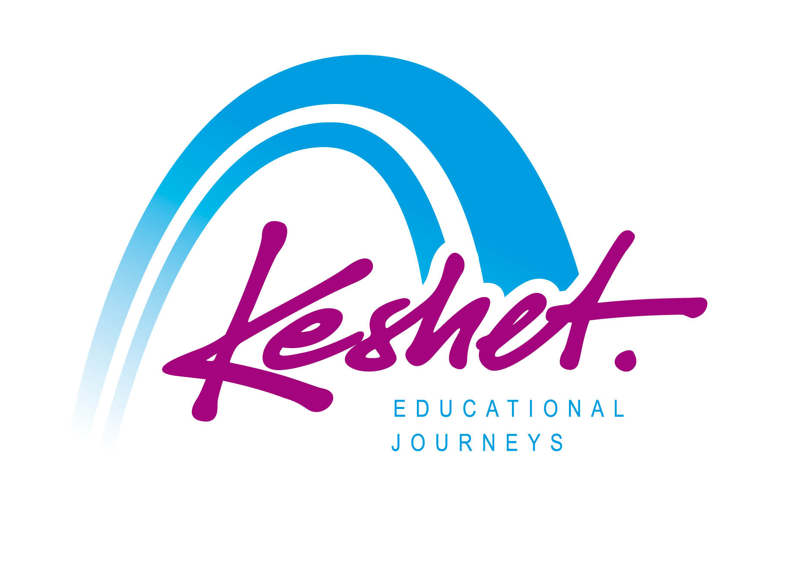
Keshet Educational Journeys
PO Box 8540 Jerusalem 91084 Israel
Phone: 972-2-671-3518 | Fax: 972-2-671-3624
danny@keshetisrael.co.il | www.keshetisrael.co.il 2

