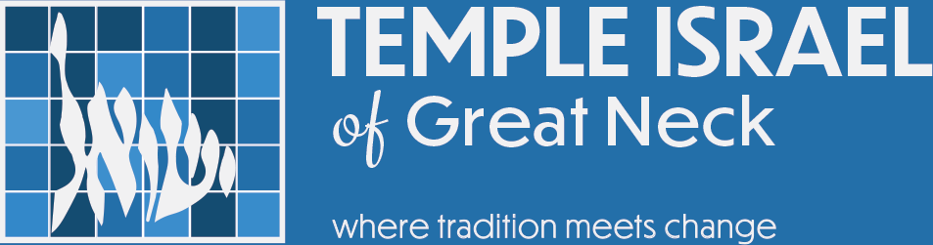

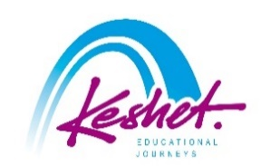
Solidarity Mission to Israel
Led by Rabbi Daniel Schweber
November 30-December 9, 2025
updated September 16
Sunday, November 30: | Israel – here we come!
- Depart for Israel; we would recommend you book flight LY2 (El Al) departing JFK at 5:00pm; the flight agent with whom we work – Claude Hakim – would be happy to help you arrange that should you wish: mrfield@verizon.net

Monday, December 1: | bruchim Habaim – welcome to Israel!
- Arrival in Israel
- For flights landing at about 4:00pm: Meet and Greet Service will greet you after passport control and take you through baggage claim and customs and over to your awaiting guide; those arriving at a different time should make their own way to the hotel – we at Keshet can help with that
- Load the bus and travel to Tel Aviv; check into the hotel
- Welcome dinner and orientation
Overnight: Tal by the Beach Hotel, Tel Aviv

Tuesday, December 2: | altruism in action
- Breakfast at hotel
- Volunteer at the Leket Distribution Center – which rescues food from hotels, restaurants and celebration halls and gives it to the needy
- Bikur Cholim – visit injured soldiers rehabbing from their injuries and pamper them with gifts
- Visit to Hostage Square in order to recall the freed hostages whom were held by Hamas from October 7th; this area – outside the Tel Aviv Museum of Art – is to be kept as a permanent site to remember the plight of the hostages
- Program with the Israeli Navy Seals (arranged with the Temple)
- Dinner on your own
Overnight: Tal by the Beach Hotel, Tel Aviv

Wednesday, December 3: | otef aza (Gaza envelope)
- Breakfast at hotel
- Departure to the south
- Volunteer work in the town Netivot, one of the towns affected by the events of October 7th
- Lunch in the dining room of Kibbutz Alumim
- Pay your respects at the site of the Reim Supernova
- Visit the collection of over 1,500 cars that were destroyed or abandoned on October 7th
- See the grassroots initiative at the Shuva Junction – which has fed tens of thousands of soldiers going into and coming out of Gaza – and meet the soldiers benefiting from it today
- Check into your hotel
Overnight: Leonardo Hotel, Beer Sheva

Thursday, December 4: | wrapping the otef with love
- Bear witness at Kibbutz Holit, learn about what they went through on October 7th and what is happening with them now (arranged with the Temple)
- Agricultural work on a farm in the area
- Discussion and veggie picking and tasting with farmer Uri Alon on the current situation and what needs to happen
- Encounter with soldiers located in the area and treat them to a BBQ dinner
- Travel to Jerusalem and check into your hotel
Overnight: Cassia Hotel, Jerusalem

Friday, December 5: | This year in jerusalem!
- Breakfast at hotel
- Meet with a political analyst for an update on what has happened in Israel of the last two years, plus a glimpse into the future
- “My Enemy, My Friend” – meet with Keshet founder Yitzhak Sokoloff and his friend, Palestinian Issam Saad, a former Gazan who has been on the Hamas’s Most Wanted list after starting an Israeli-Palestinian dialogue camp for Israeli and Palestinian youth
- Explore Jerusalem on your own and support Israel’s economy
- Return to the hotel and prepare for Shabbat
- Light Shabbat candles
- Join the scores of Israelis and Jews from around the world as they bring in Shabbat at the Western Wall
- Shabbat dinner in the hotel with lone soldiers
Overnight: Cassia Hotel, Jerusalem

Saturday, December 6: | Shabbat Shalom
- Breakfast at hotel
- Free morning in Jerusalem; you may want to:
  - Attend a local synagogue
  - See the Dead Sea Scrolls and other gems at the Israel Museum
  - Wander around the Arab Souq
  - Visit the trendy First Train Station
- Shabbat lunch in the hotel
- Walking tour of Mishaknot Shaananim and Yemin Moshe
OR
of the Christian Quarter and the Church of the Holy Sepulcher
- Musical Havdallah
- Free evening to support Israeli businesses
Overnight: Cassia Hotel, Jerusalem

Sunday, December 7: | helping hand
- Breakfast at hotel
- Volunteer packing food for Israel’s needy with Pantry Packers
- Support Israel and purchase edible treats to be given out next week at the vibrant Machane Yehuda Shuk and lunch break
- At the Stand With Us Visitors Center, obtain the tools for Israel advocacy
- Visit the National Institution Buildings and meet with the Masorti representative to the World Zionist Organization
Overnight: Cassia Hotel, Jerusalem

Monday, December 8: | putting it all together
- Breakfast at hotel
- Volunteer with Yad Sarah, putting together medical supplies
- Pay our respects to the fallen at the Mt. Herzl National Military Cemetery, including the new graves from the last year and a half
- Meet with a fellow at the Shalom Hartman Institute for a wrap up session
- Summary discussion
- Farewell dinner
- Transfer to the airport for your flight home

Tuesday, December 9: | l’hitraot – see you soon!
- Depart from Ben Gurion Airport– we recommend that you book the LY1 flight departing at 12:45am on December 8, landing in JFK at 5:45am
- Land in JFK
- Start planning your next trip to Israel!

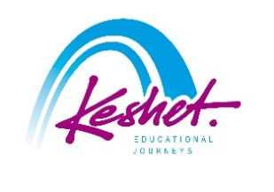
Keshet Educational Journeys
PO Box 52236 Jerusalem 9152102 Israel
Phone: 972-2-671-3518 | Fax: 972-2-671-3624
keshet@keshetisrael.co.il | www.keshetisrael.co.il

